**University of California, Irvine**

**Study Design and Procedures**

**Truth Value Judgment Survey**

**Lead Researcher**

K.J. Savinelli

Department of Cognitive Sciences

Email: [ksavinel@uci.edu](mailto:ksavinel@uci.edu)

**Faculty Advisor/Co-Researcher**

Dr. Lisa Pearl

Department of Linguistics

Department of Cognitive Sciences

Email: [lpearl@uci.edu](mailto:lpearl@uci.edu)

**Co-Researcher**

Dr. Gregory Scontras

Department of Linguistics

Email: [gscontra@uci.edu](mailto:gscontra@uci.edu)

**Setting and Mode**: The Truth Value Judgment Task (TVJT) is a way of assessing how certain utterances are interpreted in context. Although typically used with children for language acquisition research, the task also works well with adults. Our TVJT will be run on a web browser connected to a server (e.g. Mechanical Turk) and distributed to interested individuals through other social media sites (e.g. Facebook).

**Approximate Duration**: Each participant will undergo a series of trials (e.g.: 2 practice, 4 test, 3 control); common practice in past TVJT research. Where each trial takes approximately 40 seconds, the experiment would take approximately 6 minutes for participants to complete.

**The following outlines the procedures of the TVJT**:

1. Participants will see the study information sheet on their web browser, and if they decide to continue, will proceed with the survey as described below.

2. They will see an instruction slide next, explaining briefly the TVJT task. They will be informed that the initial trials are practice trials to familiarize them with the procedure. The instruction slide will look like this:

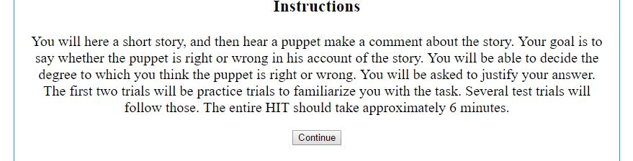

3. The practice, test, and control trials will play a video that establishes the context of the utterance. The order of test and control trials will be randomized for each participant. The following is an example video script: “Three horses decide to have some fun jumping over things. One horse suggests jumping over a cow, but the other horses say the cow is too big to jump over, and the plan is abandoned. Then the first horse jumps over the pig, which is much smaller, and challenges the other horses to do the same. The second horse jumps over the pig. The third horse considers jumping over the pig but decides that the pig looks scared and approaches him. The pig is, in fact, scared, so the third horse just talks with him instead of jumping over him.” Below is an example of a video end state with the puppet’s utterance:

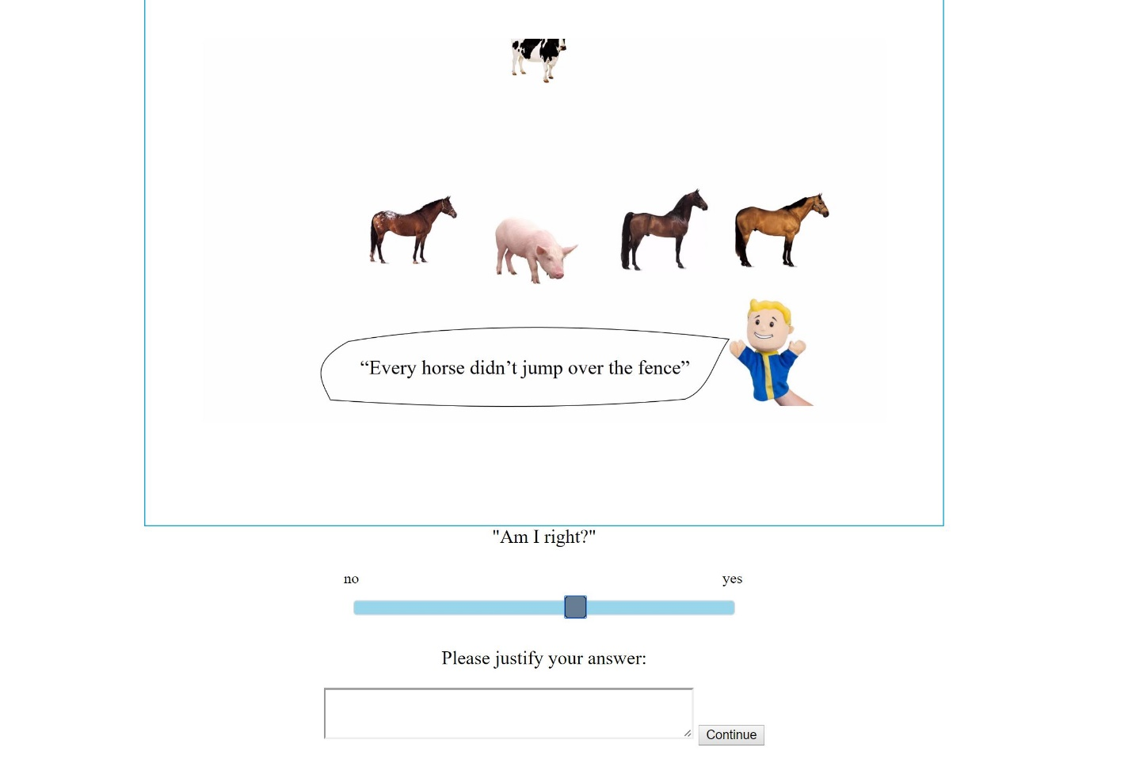

We want to test multiple utterances (for example, 4), across multiple manipulations to the context (for example, 3 manipulations per utterance). Additionally, we need different contexts (for example, 4 per utterance) for the same utterance to control for context specific variables that would impact the interpretation. This means we want approximately 48 different test videos and at least 3 control videos. Control trials are designed to make sure the participant is following instructions by having an utterance we know to be either right or wrong given adult native language proficiency.

4. After all the trials, participants will be asked to complete a voluntary participant information page. No personally identifying information will be gathered here. They will be asked questions about the Amazon Mechanical Turk HIT, gender, age, native language proficiency, level of education, enjoyment of the HIT, meta-awareness of the researchers' hypothesis, and any additional comments they have about the experiment.